Cloud Computing

Cloud computing is a technology that allows people to access and store data, programs, and services over the internet instead of using a local computer or server. This means you can use files and apps from anywhere, anytime, as long as you have an internet connection.

In cloud computing, everything is stored and managed on remote servers (called “the cloud”) provided by companies like Amazon Web Services (AWS), Microsoft Azure, and Google Cloud. It helps save money, increases flexibility, and reduces the need for powerful hardware at home or in the office.

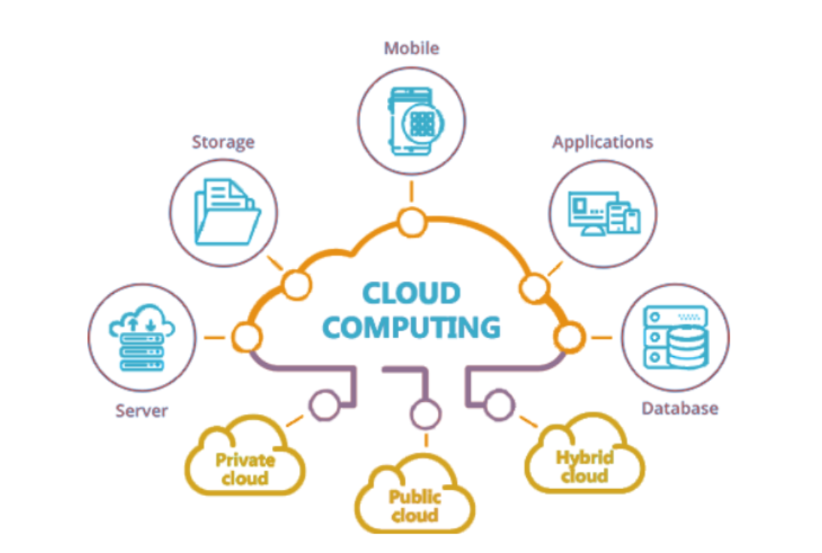

📌 Simple Example:
Think of cloud computing like using Google Drive.
Instead of saving your files (like documents, photos, or videos) on your computer, you upload them to Google Drive. Now, you can open those files from any device, like your phone or another computer, just by logging into your Google account. You don’t have to carry a USB drive or worry about losing your data if your computer crashes.
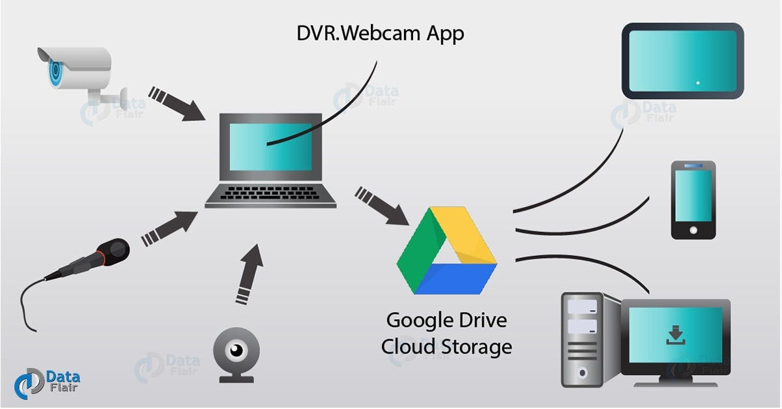

Why Cloud Computing is Useful:

· Access Anywhere: Use files or apps from any place with internet
· Saves Storage Space: No need to store everything on your computer.
· Scalable: You can add more space or power as your needs grow.
· Cost-effective: Pay only for what you use.

💡 Key Features of Cloud Computing:
📂 Storage: Save files online (like Dropbox, Google Drive).
🖥️ Software as a Service (SaaS): Use apps online (like MS Office 365, Zoom).
💻 Access Anywhere: Use your data from school, home, or phone.
💰 Pay-as-you-use: No need to buy expensive software or hardware.

☁️ Types of Cloud Computing

Public Cloud

A public cloud is a cloud service open for anyone to use. It’s owned and managed by a third-party company (like Amazon, Microsoft, or Google).
Example: Google Drive, Microsoft Azure, Amazon Web Services (AWS)

Private Cloud

A private cloud is used by only one organization. It is more secure and can be hosted either on-site (at your company) or by a private provider.
Example: A hospital using its own cloud to store patient records.

Hybrid Cloud

A hybrid cloud is a mix of public and private clouds. Some data stays private, and some are on the public cloud. They work together.
Example: A business runs its sensitive data (like employee records) in a private cloud and uses a public cloud for regular emails or customer service tools.

📊 Summary Table
Cloud Type | Who Uses It | Security | Cost | Example
Public | Everyone | Medium | Low | Google Drive, AWS
Private | One Org | High | High | Banking system cloud
Hybrid | Big Orgs | Very High | Medium | Mixing AWS + private data center

🌍 Popular Cloud Providers:

☁️ Amazon Web Services (AWS)
☁️ Microsoft Azure
☁️ Google Cloud Platform (GCP)

